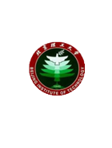

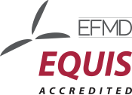
Beijing Institute of Technology School of Management and Economics

2019 Beijing Institute of Technology Management Enterprise Finance Summit

Organizer: the School of Management and Economics
Hosts: Alumni Office, Alumni Finance Club, MBA Federation
Time: Saturday, November 16,2019. 16:00.
Location: 133 of the Main Building on Zhongguancun Campus, Beijing University of Technology
Topic: "Bank and the Enterprise, Co-operation and Mutual Development"
Time | Main Contents
14:00-14：05 | School promotional film
14:05-14:10 | Speech by the School leader
14:10-14:20 | Book donation ceremony
14:20  -  16:20 | Yang Wenpu: The Current International and Domestic Economic Situation and the Change of Financial Market
14:20  -  16:20 | Gao Yu: Practicing the Great University Motto, Harvesting Wealth and Health
14:20  -  16:20 | Wang Hao: Enterprise Value Management-- Conservative and Unusual

